Note on Sample Design and Estimation Procedure of NSS 59th round

1.0 Introduction

1.0.1 The National Sample Survey (NSS), set up by the Government of India in 1950 to collect socio-economic data employing scientific sampling methods, started its fifty-ninth round from 1st January 2003.

1.0.2 Fifty-ninth round of NSS is earmarked for collection of data on land and livestock holdings, debt and investment and condition of Indian farmers besides that on household consumer expenditure and employment-unemployment. The field operations of the survey commenced on 1st January 2003 and will continue up to 31st December 2003.

1.0.3 Data to be collected in this round relate to the fixed period of the agricultural year July 2002 – June 2003. Hence the calendar year of 2003 has been considered to be the most desirable survey period for this enquiry. In order to reduce the recall error, the total information relating to each sample household are collected in two visits. The first visit (January to August) broadly covers the Kharif season of the agricultural year 2002 – 2003 and the second (September to December) the corresponding Rabi season.

2.1 Subject Coverage: The 59th round of NSS covers land and livestock holdings and debt and investment. It has also been decided to integrate situation assessment survey for Indian farmers with the current round of survey. In addition, annual survey of consumer expenditure and employment - unemployment are also being conducted.

However, situation assessment survey is covering only the rural sector since the agricultural activity is pre-dominantly a rural phenomenon and the diversity of farming activities as well as farmers’ situations is more pronounced in the rural areas.

SAS is being conducted in the central sample for all States/UTs. In the state sample, only Andhra Pradesh, Chandigarh, Gujarat, Maharashtra, Merghalaya, Orissa & Tripura are participating in SAS.

2.2 Geographical Coverage: The survey covers the whole of the Indian Union except (i) Leh (Ladakh) and Kargil districts of Jammu & Kashmir, (ii) interior villages of Nagaland situated beyond five kilometres of the bus route and (iii) villages in Andaman and Nicobar Islands which remain inaccessible throughout the year.

2.3 Period of Survey and Work Programme: As already mentioned, the survey period of this round is the calendar year of 2003 i.e. January to December, 2003.

2.3.1 Visits 1 & 2: Each sample FSU is being visited twice during this round. Since the workload of the first visit (i.e. visit 1) is more, the first visit continues till the end of August 2003. Thus, period of the first visit is January – August 2003 and that of the second visit (i.e. visit 2) is September – December 2003.

The listing schedules (sch 0.0) are canvassed only in the first visit. Schedules 18.1, 18.2 and 33 are canvassed in independent sets of sample households. Each sample household is visited twice. Visit 1 and visit 2 schedules are to be canvassed in the same set of sample households
during first and second visit respectively.
Of the four households selected for schedule 1.0, two are canvassed in the first visit and the remaining two in the second visit.

As per the programme, the villages/blocks visited in the first two months of the first visit are revisited in the first month of the second visit and so on i.e. villages/blocks visited in January & February, March & April, May & June and July & August are revisited in September, October, November and December respectively.

2.3.2 Sub-rounds: The survey period of the round are divided into two sub-rounds. Sub-round one consists of the first half of the survey period of each visit while sub-round two consists of the remaining period. The sub-round number is given in the sample list. Because of the arduous field condition, this restriction is not strictly enforced in Andaman and Nicobar Islands, Lakshadweep and rural areas of Arunachal Pradesh and Nagaland.

2.4 Schedules of Enquiry: The following schedules are being canvassed:

Schedule 0.0 : | list of households
Schedule 18.1 : | land and livestock holdings
Schedule 18.2 : | debt and investment
Schedule 33 : | situation assessment survey of farmers
Schedule 1.0 : | household consumer expenditure

  - Participation of States: In this round all the States and Union Territories except Andaman & Nicobar Islands, Dadra & Nagar Haveli and Lakshadweep are participating at least on an equal matching basis. The following is the matching pattern of the participating States/UTs.

Nagaland (Urban) | : triple
J & K , Manipur & Delhi | : double
Goa, Maharashtra (Urban) | : one and half
Remaining States/UTs | : equal

Andhra Pradesh, Chandigarh, Gujarat, Maharashtra, Merghalaya, Orissa & Tripura are participating in SAS for the state sample.

3.4 Sample Design

3.4.1 Broad design: A stratified multi-stage design has been adopted for the 59th round survey. The first stage unit (FSU) is the census village in the rural sector and UFS block in the urban sector. The ultimate stage units (USUs) are households in both the sectors. Hamlet-groups / sub-blocks constitute the intermediate stage whenever these are formed in the selected FSU.

3.4.2 Sampling Frame for First Stage Units: For rural areas, the list of villages (panchayat wards for Kerala) as per Population Census 1991 and for urban areas the latest UFS frame have been used as sampling frame. For stratification of towns by size class, provisional population of towns as per Census 2001 have been used.

3.4.3 Stratification

3.4.3.1 Rural Sector: Two special strata have been formed at the State/ UT level, viz.,

Stratum 1: all FSUs with population between 0 to 50 and
Stratum 2: FSUs with population more than 15,000.

Special stratum 1 was formed whenever at least 50 such FSUs were found in a State/UT. Similarly, special stratum 2 was formed if at least 4 such FSUs were found in a State/UT. Otherwise, such FSUs were merged with the general strata.

From FSUs other than those covered under special strata 1 & 2, general strata were formed and its numbering started from 3. Each district of a State/UT was normally treated as a separate stratum. However, if the census rural population of the district was greater than or equal to 2 million as per population census 1991 or 2.5 million as per population census 2001, the district was split into two or more strata by grouping contiguous tehsils. However, in Gujarat, some districts were not wholly included in an NSS region. In such cases, the part of the district falling in an NSS region constituted a separate stratum.

3.4.3.2 Urban Sector: In the urban sector, strata have been formed within each NSS region on the basis of size class of towns as per Population Census 2001. The stratum numbers and their composition (within each region) are given below.

stratum 1 : | all towns with population less than 50,000
stratum 2 : | all towns with population 50,000 or more but less than 2 lakhs
stratum 3 : | all towns with population 2 lakhs or more but less than 10 lakhs
stratum 4, 5, 6,... : | each city with population 10 lakhs or more

The stratum numbers remained as above even if, in some regions, some of the strata did not exist.

3.4.4 Total Sample Size (FSUs): 10608 FSUs have been allocated at all-India level on the basis of investigator strength in different States/UTs for central sample and 11496 for state sample.

3.4.5 Allocation of Total Sample to States and UTs: The total number of sample FSUs has been allocated to the States and UTs in proportion to provisional population as per Census 2001 subject to the availability of investigators ensuring more or less uniform work-load.

3.4.6 Allocation of State/UT Level Sample to Rural and Urban Sectors: State/UT level sample size has been allocated between two sectors in proportion to provisional population as per Census 2001 with 1.5 weightage to urban sector subject to the restriction that urban sample size for bigger states like Maharashtra, Tamil Nadu etc. would not exceed the rural sample size. Earlier practice of giving double weightage to urban sector has been modified considering the fact that two main subjects of enquiry (sch. 18.1 and sch 33) are rural based and there has been considerable growth in urban population over the years. More samples have been allocated to rural sector of Meghalaya state sample at the request of the DES, Meghalaya.

3.4.7 Allocation to Strata: Within each sector of a State/UT, the respective sample size was allocated to the different strata in proportion to the stratum population as per census 2001. Allocations at stratum level was adjusted to a multiple of 2 with a minimum sample size of 2. However, a multiple of 4 FSUs was allocated to a stratum wherever possible.
3.4.8 Selection of FSUs: FSUs were selected with Probability Proportional to Size with replacement (PPSWR), size being the population as per Population Census 1991 in all the strata for rural sector except for stratum 1. In stratum 1 of rural sector and in all the strata of urban sector, selection was done using Simple Random Sampling without replacement (SRSWOR). Samples were drawn in the form of two independent sub-samples both in rural and urban sectors.

4. Selection of Hamlet-groups/Sub-blocks / Households

4.1 Formation of Hamlet-group/Sub-block: Large villages/blocks having approximate present population 1200 or more are divided into a suitable number of hamlet-groups/sub-blocks as given below:

approximate present population  of the sample village/block | no. of hamlet-groups/sub-blocks  to be formed
less than 1200 | 1  (no hamlet-groups/sub-blocks formation)
1200 to 1799 | 3
1800 to 2399 | 4
2400 to 2999 | 5
3000 to 3599 | 6
…………..and so on

For rural areas of Himachal Pradesh, Sikkim, Nagaland and Poonch, Rajouri, Udhampur, Doda districts of Jammu and Kashmir, the number of hamlet-groups formed is as follows.
approximate present population of the sample village | no. of hamlet-groups/sub-blocks  to be formed
less than 600 | 1  (no hamlet-groups/sub-blocks formation)
600 to 899 | 3
900 to 1199 | 4
1200 to 1499 | 5
.………..and so on

Hamlet-groups / sub-blocks are formed by more or less equalising population. Two hamlet-groups / sub-blocks are selected from a large village or block by SRSWOR. Listing and selection of the households are done independently in the two selected hamlet-groups/sub-blocks so formed.

4.2 Formation of Second Stage Strata (SSS) for Different Schedule Types:

4.2.1 Schedule 18.1: Land Holding Survey (LHS):

4.2.1.1 Rural: Four SSS are formed in the rural sector. SSS 1 consists of all the households possessing land less than 0.005 hectares. SSS 2, 3 & 4 are formed by the households possessing 0.005 hectares of land or more. These three strata be formed are as under:
From the data of NSS 48th round, the households having land area 0.005 hectares or more have been considered. Two cut –off points, X and Y, have been determined at State/UT level in such a way that 40% of these households possess land area less than X, 40% possess land area between X & Y and 20% possess land area greater than Y.

Listed households with land less than X form SSS 2, those with land between X & Y constitute SSS 3 and those with land more than Y are in SSS 4.

Thus, composition of SSS for sch. 18.1 in the rural sector is as follows:

SSS 1: | households with L less than 0.005 hectare
SSS 2: | households with L equal to or more than 0.005 but less than X
SSS 3: | households with L equal to or more than X but less than Y
SSS 4: | households with L equal to or more than Y
where L is area of land in hectares possessed by the household

4.2.1.2 Urban: Four SSS are formed as under:

First, three cut-off points, viz. A, B & C, at State/UT level have been determined using the NSS 55th round data in such a way that 30% of the households have MPCE less than A, 30% have MPCE more than or equal to A but less than B, 30% have MPCE more than or equal to B but less than C and the rest 10% of the households have MPCE more than or equal to C.

The composition of SSS for sch. 18.1 in the urban sector are as follows:

SSS 1: | households with MPCE less than A (say, MPCE class 1)
SSS 2: | households with MPCE equal to or more than A but less than B (say, MPCE class 2)
SSS 3: | households with MPCE equal to or more than B but less than C (say, MPCE class 3)
SSS 4: | households with MPCE equal to or more than C  (say, MPCE class 4)

4.2.2 Schedule 18.2: Debt and Investment Survey (AIDIS):

4.2.2.1 Rural: Seven SSS are formed in the rural sector as under:

SSS 1: | indebted households belonging to rural LHS SSS 1
SSS 2: | not indebted households belonging to rural LHS SSS 1
SSS 3: | indebted households belonging to rural LHS SSS 2
SSS 4: | not indebted households belonging to rural LHS SSS 2
SSS 5: | households indebted to institutional agencies with or without being indebted to non-institutional agencies and belonging to rural LHS SSS 3 & 4
SSS 6: | households indebted to non-institutional agencies only and belonging to rural LHS SSS 3 & 4
SSS 7: | not indebted households belonging to rural LHS SSS 3 & 4

4.2.2.2 Urban: Seven SSS are formed as under:

SSS 1: | indebted households belonging to MPCE class 1
SSS 2: | not indebted households belonging to MPCE class 1
SSS 3: | indebted households belonging to MPCE class 2
SSS 4: | not indebted households belonging to MPCE class 2
SSS 5: | households indebted to institutional agencies with or without being indebted to non-institutional agencies and belonging to MPCE classes 3 & 4
SSS 6: | households indebted to non-institutional agencies only and belonging to MPCE classes 3 & 4
SSS 7: | not indebted households belonging to MPCE classes 3 & 4

4.2.3 Schedule 33: Situation Assessment Survey (SAS): The schedule is being canvassed in the rural sector of central sample. A few States are also participating in state sample. The composition of second-stage stratification is as follows:

SSS 1: | households belonging to rural LHS SSS 1 and engaged in farming activity during last 365 days
SSS 2: | households belonging to rural LHS SSS 2 and engaged in farming activity during last 365 days
SSS 3: | households belonging to rural LHS SSS 3 and engaged in farming activity during last 365 days
SSS 4: | households belonging to rural LHS SSS 4 and engaged in farming activity during last 365 days

4.2.4 Schedule 1.0: Consumer Expenditure Survey: Two SSS are formed:

Rural:
SSS 1: | households possessing land < Y
SSS 2: | households possessing land ≥ Y
Urban:
SSS 1: | households belonging to MPCE classes 1, 2 and 3
SSS 2: | households belonging to MPCE class 4
.
Out of the four households selected for sch. 1.0, two households are covered in visit 1 and two in visit 2.

4.3 Allocation and Selection of Sample Households: Two households are selected from each SSS of each type of schedule. In case of hamlet group/ sub-block formation, one household is selected from each (hg/sb) × SSS. The total number of households to be surveyed in an FSU is given below for each schedule type:

schedule | rural | urban
18.1 | 8 | 8
18.2 | 14 | 14
33 | 8 | -
1.0 | 4 | 4

Sample households for each type of schedule are selected by SRSWOR in each SSS of each hg/sb.
5. Estimation Procedure

5.1 Notations:
s = subscript for s-th stratum
m = subscript for sub-sample (m =1, 2)
i = subscript for i-th FSU [village (panchayat ward) / block]
d = subscript for a hamlet-group/sub-block (d = 1, 2)
j = subscript for j-th second stage stratum of an FSU/ hg/sb
k = subscript for k-th sample household under a particular second stage stratum within an FSU/ hg/sb
D = total number of hg’s/sb’s formed in the sample village (panchayat ward) / block
D* = 1 if D = 1
= D / 2 for FSUs with D > 1
N = total number of FSUs in rural stratum 1 or in any urban stratum
Z = total size of a rural stratum other than stratum 1 (= sum of sizes for all the FSUs of a rural stratum other than stratum 1)
z = size of sample village used for selection.
n = number of sample village / block surveyed including zero cases but excluding casualty for a particular sub-sample and stratum.
H = total number of households listed in a second-stage stratum of a hamlet-group/sub-block of sample FSU
h = number of households surveyed in a second-stage stratum of a hamlet-group/sub-block of sample FSU
x, y = observed value of characteristics x, y under estimation
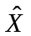, = estimate of population total X, Y for the characteristics x, y

Under the above symbols,
y_{smidjk} = observed value of the characteristic y for the k-th household in the j-th second stage stratum of the d-th hg/sb (d = 1, 2) of the i-th FSU belonging to the m-th sub-sample for the s-th stratum;
However, for ease of understanding, a few symbols have been suppressed in following paragraphs where they are obvious.

5.2 Formulae for Estimation of Aggregates for a particular Sub-sample and Stratum in Rural / Urban sector:
A) Schedule 0.0:
Rural:
- Estimation formula for stratum 1 (i.e. special stratum at State/UT level )
i) For estimating the number of households possessing a characteristic:
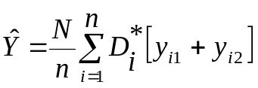

where 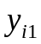 , 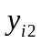 are the total of observed values for the characteristic y belonging to hg’s 1 & 2 of the i-th FSU respectively.
ii) For estimating the number of villages possessing a characteristic:
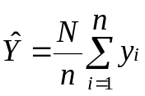
where 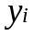 is taken as 1 for sample villages possessing the characteristic and 0 otherwise.

(b) Estimation formula for other strata:
i) For estimating the number of households possessing a characteristic:
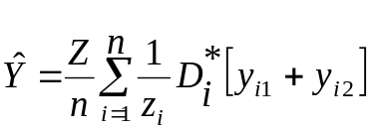
ii) For estimating the number of villages possessing a characteristic:
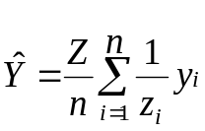

Urban:
Estimation formula for an urban stratum:

,

where 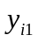 and are the totals of observed values for the characteristic y belonging to sub-blocks 1 and 2 respectively, of the i-th FSU.

B) Schedules 1.0 / 18.1 / 18.2 / 33:
Rural:
- Estimation formula for stratum 1:
(i) For households selected in j-th second stage stratum:

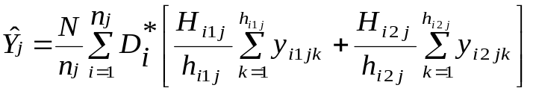

(ii) For all selected households:
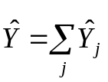

(b) Estimation formula for other strata:
(i) For households selected in j-th second stage stratum:

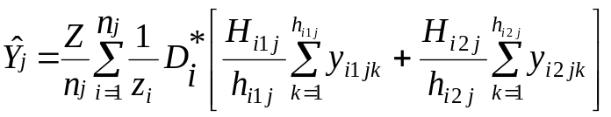

(ii) For all selected households:

Urban:
(a) Estimation formula for a stratum:
(i) For households selected in j-th second stage stratum:

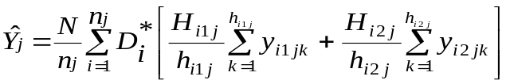

(ii) For all selected households:

Note: i) Schedule 33 has been canvassed in rural sector only
ii) Values of j for different schedules are as follows:
for sch. 1.0, j = 1 or 2;
for sch. 18.1, j = 1, 2, 3 or 4;
for sch. 18.2, j = 1, 2, ….., 6 or 7 and
for sch. 33, j = 1, 2, 3 or 4
iii) Estimates in respect of joint operational holdings: In the case of joint operational holdings operated by the sample household jointly with other household(s), the value of a characteristic of the operational holding will be first multiplied by the percentage share of land of the sample household(s) and then the higher estimates will be built up.

5.3 Overall Estimate for Aggregates:
Overall estimate for aggregates for a stratum (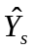) based on two sub-samples is obtained as:
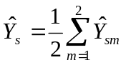

5.4 Overall Estimate of Aggregates at State/UT/all-India level:
The overall estimate 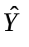at the State/ UT/ all-India level is obtained by summing the stratum estimates over all strata belonging to the State/ UT/ all-India.

5.5 Estimates of Ratios:
Let and be the overall estimate of the aggregates Y and X for two characteristics y and x respectively at the State/ UT/ all-India level.
Then the combined ratio estimate 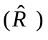of the ratio 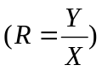 will be obtained as
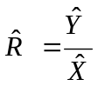

5.6 Estimates of Error:
The estimated variances of the above estimates will be as follows:

- For aggregate :

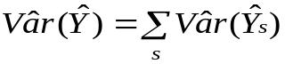

where 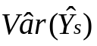 are as given below.

- For strata with PPSWR selection at first stage (i.e. for all rural strata except stratum 1):

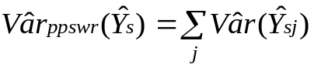

where 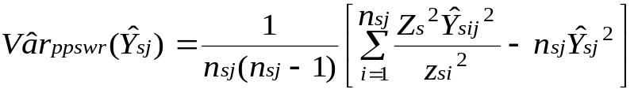 ,

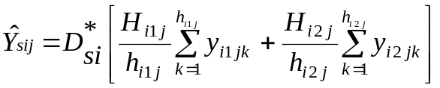

b) For strata with SRSWOR selection at first stage (i.e. for rural stratum 1 and all urban strata):

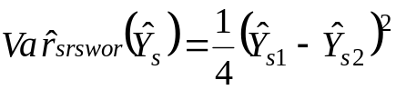 ,

where 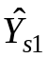 and 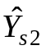 are the estimates for sub-sample 1 and sub-sample 2 respectively for stratum ‘s’.

B) For ratio 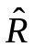 :

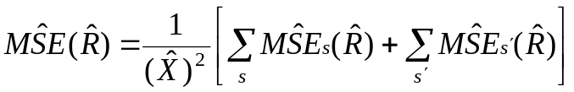

where s, s' indicate respectively the strata with PPSWR and SRSWOR selection at first stage.

a) For strata with PPSWR selection at first stage (i.e. for all rural strata except stratum 1):

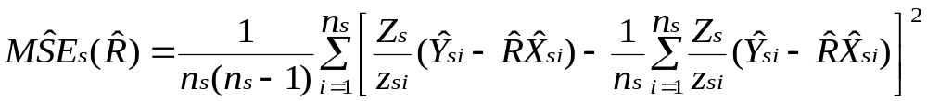

where

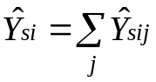 , 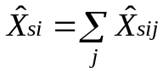 ,

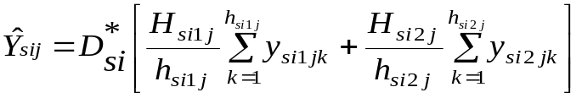,

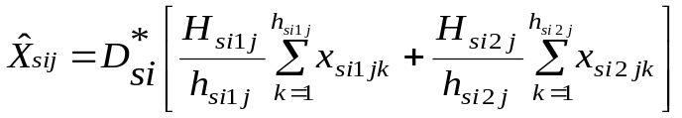

b) For strata with SRSWOR selection at first stage (i.e. for rural stratum 1 and all urban strata):

C) Estimates of RSE:

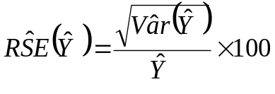

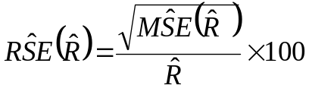

6. Multipliers:

The formulae for multipliers for a sub-sample and schedule type are given below:

sch type | stratum | formula for multipliers
sch type | stratum | hg / sb 1 | hg / sb 2
0.0 | rural stratum 1 and all urban strata | 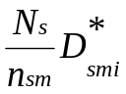 | 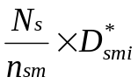
0.0 | rural  s1 | 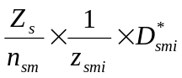
1.0 | rural stratum 1 and all urban strata | 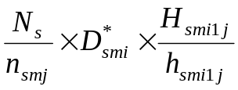 ,  j = 1, 2 | 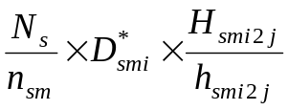 ,  j = 1, 2
1.0 | rural  s1 | 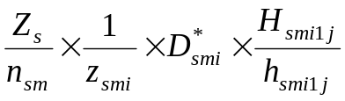 ,  j = 1, 2 | 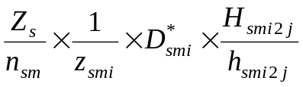 ,  j = 1, 2
18.1  / 33 | rural stratum 1 and all urban strata | ,  j = 1, 2, 3, 4 | ,  j = 1, 2, 3, 4
18.1  / 33 | rural  s1 | ,  j = 1, 2, 3, 4 | ,  j = 1, 2, 3, 4
18.2 | rural stratum 1 and all urban strata | ,  j = 1, 2, …., 6, 7 | ,  j = 1, 2, …., 6, 7
18.2 | rural  s1 | 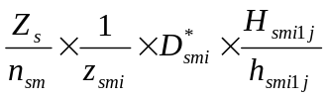 ,  j = 1, 2, …., 6, 7 | ,  j = 1, 2, …., 6, 7

Note: (i) For estimating any characteristic for any domain not specifically considered in sample design, indicator variable may be used.
(ii) Multipliers have to be computed on the basis of information available in the listing schedule irrespective of any misclassification observed between the listing schedule and detailed enquiry schedule.
(iii) For estimating number of villages possessing a characteristics, 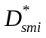 = 1 in the relevant multipliers and there will be only one multiplier for the village.

7. Treatment for zero cases, casualty cases etc.:

7.1 While counting the number of FSUs surveyed (n_{sm} ) in a stratum, all the FSUs with survey codes 1 to 6 in schedule 0.0 will be considered. In addition, for a particular schedule if no USU is available in the frame then also that FSU will be treated as surveyed in respect of that schedule. However, if the USUs of a particular schedule type are available in the frame of the FSU but none of these could be surveyed then that FSU has to be treated as casualty and it will not be treated as surveyed in respect of that schedule.

7.2 Casualty cases: FSUs with survey code 7 as per schedule 0.0 are treated as casualties. In addition to this, an FSU, although surveyed, may have to be treated as casualty for a particular schedule type and a particular second stage stratum as given in the following para:

7.2.1 FSUs with survey codes 1 and 4 as per schedule 0.0 having number of households in the frame of j-th second stage stratum greater than 0 but number of households surveyed according to data file, considering both hg/sb together, as nil (i.e. H_{i1j} + H_{i2j} >0 but h_{i1j} + h_{i2j} =0) will be taken as casualties for j-th second stage stratum.

All the FSUs with survey codes 1 to 6 as per schedule 0.0 minus the number of casualties as identified above will be taken as the number of surveyed FSUs (n_{smj} ) for that stratum × second stage stratum.

When casualty for j-th second stage stratum occurs for a particular hg/sb but not for the other hg/sb, the FSU will not be treated as casualty but some adjustments in the value of H for the other hg/sb will be done as follows:
- Suppose for hg/sb 1, H_{i1j} > 0 but h_{i1j} = 0 while for hg/sb 2, H_{i2j} > 0 and h_{i2j} > 0. In that case 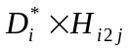 will be replaced by H_{i1j} + in the formula for multiplier of segment 2.

(ii) Suppose for hg/sb 1, H_{i1j}>0 and h_{i1j} > 0 while for hg/sb 2, H_{i2j}>0 but h_{i2j}=0. In that case H_{i1j} will be replaced by H_{i1j} + in the formula for multiplier of hg/sb 1.

It may be noted that n_{smj} will be same for hg/sb 1 & 2 of an FSU.

8. Treatment in cases of void second-stage strata/sub-strata /strata/NSS region at FSU or household level
8.1 A stratum may be void because of the casualty of all the FSUs belonging to the stratum. This may occur in one sub-sample or in both the sub-samples. If it relates to only one sub-sample, then estimate for the void stratum may be replaced with the estimate as obtained from the other sub-sample for the same stratum.

8.2 When a stratum is void in both the sub-samples, the following procedure is recommended:
Case(I): Stratum void cases at FSU levels (i.e. all FSUs having survey code 7):
- If a rural stratum, except stratum 1, is void then it may be merged with a similar stratum within the same NSS region. However, if rural stratum 1 is void for any State/UT, it will not be merged with other stratum and remarks to that effect may be added in appropriate places.
ii) If an urban stratum is void then it may be merged with another stratum within the same NSS region
iii) If all the strata within an NSS region is void, it may be excluded from the coverage of the survey. The state level estimates will be based on the estimates of NSS regions for which estimates are available.

Case (II): Stratum void case at second stage stratum level (i.e. all the FSUs are casualties for a particular second stage stratum):
An FSU may be a casualty for a particular second stage stratum although survey code is not 7. If all the FSUs of a stratum become casualties in this manner for a particular second stage stratum, the stratum will become void. The adjustment for this type of stratum void case may be done according to the following guidelines.
The adjustment will be made involving other strata (within NSS region) of the State/U.T. Suppose A, B, C, and D are the four strata in the State/UT/Region and stratum C is void for j-th second stage stratum. If 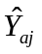, 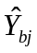and 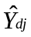are the aggregate estimates for the strata A, B and D respectively, then the estimate 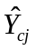 for stratum C may be obtained as 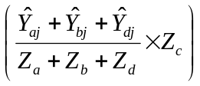where Z_{a}, Z_{b}, Z_{c} and Z_{d} are the sizes of strata A, B, C and D respectively.

9.1 Reference to the values of Z_{s}, N_{s}, n_{s}, z_{si}, D_{si}, D*_{si}, H_{si1j}, h_{si1j}, H_{si2j}, h_{si2j:}
- Values of Z_{s} , N_{s} and allotted n_{s} for the whole round are given in appendix Table 2 for rural sector and in appendix Table 3 for urban sector.
- n_{s} should not be taken from the tables. The values of n_{sm} for each sub-sample are to be obtained following the guidelines given in para 7 above and used for tabulation. It includes uninhibited and zero cases but excludes casualty cases.
- The value of z_{si} is to be taken from the column of sample list under the heading “frame population”. Value of D_{si} are to be taken from item 16 of block 1, sch 0.0. D_{si}* is to be calculated from the value of D_{si}.
- Values of H_{si1j}, H_{si2j} are to be taken from col.(5), block 5 of sch 0.0 for respective hg/sb.
- The value of h_{si1j} and h_{si2j} should not be taken from col (6), block 5 of sch.0.0. The figures should be obtained by counting the number of households in the data file excluding the casualty households.

9.2 Number of FSUs allocated for each State/UT is given in appendix Table 1. The list of 27 towns with population 10 lakhs or more are listed in appendix Table 4.

******

